Assembly LMV-F400

Safety awareness, please be aware of your environment at all times. Some items like extension cords, air hoses etc. could be a trip hazard. Screws, FOD any item on the floor like fluids from spills could be a potential slip hazard. Lifting heavy objects over 50 pounds, use a 2 person lift procedure or/and lifting equipment if available. Wear the required safety equipment and report/or resolve any unsafe situations.
- Safety glasses for drilling, taping, cutting materials, sanding, use of any pneumatic tools, machinery that create a hazard including dust, chips and FOD, handling corrosive fluids and solvents that could cause eye irritation including sealants, adhesives, acetone and grease.
- Latex gloves for handling corrosive fluids and solvents that could irritate the skin including adhesives, acetone and sealants.
- Dust mask and/or respirator if applicable for any sanding, polishing and application of paint solvents.
- Steel toe shoes are required at all times in all production areas

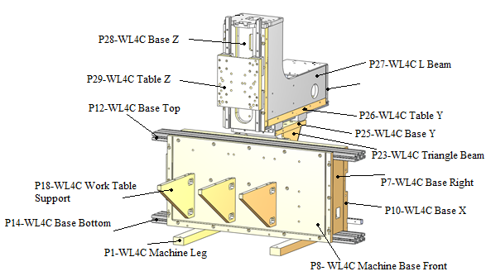

Tools:
- 3 mm Allen Wrench
- 4 mm Allen Wrench
- 5 mm Allen Wrench
- 6 mm Allen Wrench
- Oil Canister
- Acetone
- Paper Towel
- Parallel
- Hand Drill
- 4.3 mm Drill Bit
- 6.0 mm Drill Bit
- 6.8 mm Drill Bit
- M5x0.8 Tap
- M8x1.25 Tap
- Tap Magic
- Guideway Cart
- Dial Indicator
- 5 C-clamps
- Iron Plate
- Alignment table

Procedure: | Inventory:
- Check for threaded holes at the ends of top and bottom bases. If not there, use M6x1.0 tap to thread the ends of both the top and bottom bases. Clean all three X, Y and Z bases with acetone. | - 1 P12-WL4C base top (1000012)  - 1 P14-WL4C base bottom  (1000014)  - 1 P88-WL4D base center  (1000086)
- Clean base X’s guideway channels and rails with acetone. Apply a light coat of oil to rails and install them. The arrows engraved in the guideway rails must be pointing down. | - 1 P10-WL4C base X  (1000010)  - 2 WL-400 Guideway X Axis  (1200016)  - M5X25 socket screws  (1100022)
- Clean table Y’s guideway channels and rails with acetone. Apply a light coat of oil to rails and install them. For proper installation, the guideway rails should protrude more from the back of the base than the front. | - 1 P26-WL4C table Y  (1000026)  - 2 WL-400 Guideway Y Axis (1200018)  - 16 M5X20 socket screws  (1100020)
- Clean base Z’s guideway channels and rails with acetone. Apply a light coat of oil to rails and install them. The end of the guideway rail should line up with lower edge of the base. | - 1 P28-WL4C base Z  (1000028)  - 2 WL-400 Guideway Z Axis  (1200019)  - 10 M5X20 socket screws  (1100020)
- Inspect guideway rails have been installed properly by checking them with a dial indicator mounted on a railway cart. Max error allowed per 100 mm is ±0.02.

- Mount top, center, and bottom bases to base X by screwing T-nuts into the screws indicated and sliding the bases from the side. Mount screws and T-nuts to machine front base and slide it into the base X assembly. | - 1 P8-WL4C machine base front (1000008)  - 14 M6X30 socket screws  (1100032)  - 16 M6X16 socket screws  (1000029)  - 30 T-nuts  (1100061)
- Place base left closed and base right on their respective sides and mount all crews needed, leave them loose for now. | - 1 P80-WL4D base left closed  (1000080)  - 1 P7-WL4C base right (1000007)  - 6 M6X10 button heads  (1100024)  - 8 M6X16 socket screws  (1100029)  - 6 M6X30 socket screws  (1100032)
- Mount control tower to the right side of the machine with the longer side of the tower pointing up. Tighten screws all the way. | - 1 P19-WL4C control tower  (1000019)  - 4 M6X12 socket screws  (1100026)
- Use a parallel to make sure the base left open is flat against base X. If it is, tighten screws between base left and base X first, then tighten screws in the front lower side of base left. Next, tighten screws between base right and base X.

- Remove control tower.

- Flip machine upside down and drill holes for the legs, use a 6.8 mm drill bit and a M8 tap, make sure legs are parallel and the right distance apart. | - 2 P1-WL4C machine leg  (1000001)  - 4 M8X40 socket screws  (1100037)
- Insert steel dowels into Triangle Beams with red loctite and assemble Tables X and base Y with them. Make sure Triangle Beams have the same identification number. The triangle beam with wire openings should be on the right side. | - 4 ¼” dowel pins  (1100053)  - 2 P23-WL4C triangle beam  (1000023)  - 1 P22-Wl4C table X  (1000022)  - 1 P25-WL4C base Y  (1000025)  - 11 M6X20 socket screws  (1100030)  - 7 M6X16 socket screws  (1100029)
- Insert steel dowels into L Beams with red loctite and assemble table Y and base Z with it. Make sure L Beams have the same identification number. The wire opening should be on the left side of the assembly. | - 2 P27-WL4C L beams  (1000027)  - 8 ¼” dowels ()  (1100053)  - 22 M6X25 socket screws  (1100031)
- Install guideway carts to triangle assembly and table Z.  Metal side of carts should face up in the triangle assembly, for table Z they should all face the same direction, right or left. Once all carts are installed slide triangle assembly into base X guideway rails and table Z into base Z guideway rails. | - 1 P29-WL4C table Z  (1000029)  - 12 Guideway Carts  (1200015)  - 8 M4X20 socket screws  (1100010)  - 40 M4X16 socket screws  (1100009)
- Insert steel dowels into work table supports and mount them to machine base front. (picture of a 3 axis mill) | - 4 ¼” dowels  (1100053)  - 4 P18-WL4C work table support (1000018)  - 8 M6X20 socket screws  (1100030)
- For 4th Axis machines, only add three work table supports.

- Align machine’s 3 axes using aligning table and dial indicator. Follow pictures for alignment table setup.

Ball Screw LMV-F400
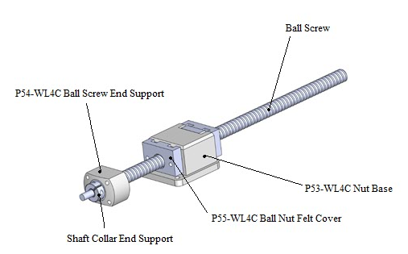
Tools:

- 2 mm Allen Wrench
- 4 mm Allen Wrench
- 5 mm Allen Wrench
- Grease
- Oil
- Red Loctite
- Scissors
- Hand Drill
- 4.3 mm Drill Bit
- 5.1 mm Drill Bit
- 6.0 Drill Bit
- M6X1.0 Tap

Procedure: | Inventory:
- Clean mating surfaces on ball screw and nut base. Insert X, Y, and Z Ball Screws into Accu Tech ball nut bases and screw them in tightly to the four corner holes. | - 1 WL-400 X Ball Screws  (1200002)  - 1 WL-400 Y Ball Screws  (1200004)  - 1 WL-400 Z Ball Screws  (1200005)  - 3 P53-WL4C nut base accu tech (1000053)  - 6 P55-WL4C ball nut felt cover (1000055)  - 12 M5X16 socket screws  (1100019)
- Cut about 3 mm off the wool washer tangent to the circle and another cut through the washer on the opposite side. Soak washers in oil and insert them into ball nut felt cover. Screw in felt cover into ball nut base. | - 6 Wool Felt Washer  (1200014)  - 6 M5X30 socket screws  (1100023)  - 6 M5x20 socket screws  (1100020)
- Insert 7000B bearings into Ball Screw End Support and apply grease. Insert 10mm washer before covering with Thrust Bearing Cover. | - 6 7000B Bearing  (1200022)  - 3 P54-WL4C Ball Screw End Support (1000054)  - 6 10mm washer (1100156)  - 6 Thrust Bearing Cover  (1200023)
- Mount ball screw end supports to ball screws, use Shaft Collars to hold end supports in place. Apply red Loctite to thread. Adjust tightness until bearings feel smooth with no play along the ball screw axis. Tighten the shaft collar screw. | - 3 Shaft Collar End Support  (1200024)
- Mount Ball Screws into Table X, base Y, and table Z. Apply grease to end support delrin and place them on end supports. Install servo bases to secure ball screw end supports. Leave M5X16 screws loose. | - 1 P81-WL4D servo X direct drive base (1000081)  - 2 P82-WL4D servo YZ direct drive base (1000082)  - 3 P56-WL4C ball screw end support delrin (1000056)  - 8 M6X20 socket screws  (1100030)  - 22 M6X16 socket screws  (1100029)  - 12 M5X16 socket screws ()  (1100019)
- Drill out two missing holes for servo X base to 5.1 mm and tap with M6X1.0 tap. Remove servo base and clean area.
- Mount servo X base back and install servo couplings, tighten the ball screw side all the way. | - 3 8-9 servo couplings  (1200028)
- Move ball screw until the nut base is as close as possible to the ball screw end support in all axes. Carefully tighten M5X16 screws while checking the ball screw remains smooth.
- Mount Fanuc servos to the machine using servo columns and specified screws, leave everything loose. | - 12 servo columns  (1200029)  - 3 Fanuc servos  - 12 M5X55 socket screws  (1100098)
- Tighten the coupling on the servo side until it starts moving the servo shaft when rotated, then loosen coupling until it stops moving it. Tighten the servo columns first and then the coupling all the way.

LMV-F400 Tub Assembly
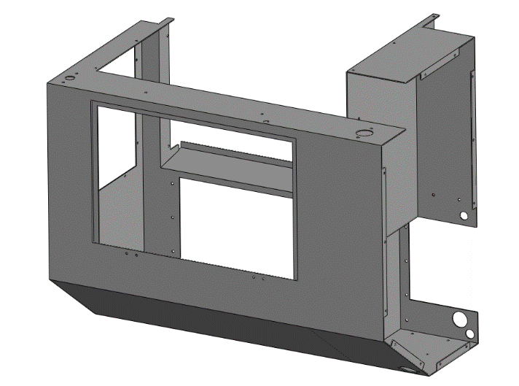
Tools:
- 3 mm Allen Wrench
- 4 mm Allen Wrench
- 5 mm Allen Wrench
- 10 mm wrench
- Phillips Head Screwdriver
- Silicone

Procedure: | Inventory:
- Install a Y splash guard base to the front of the Y base before mounting the tub. | - 1 Y splash guard base  (1000069)  - 2 M5X8 conical screws  (1100108)
- Clean the front base and apply white grease to the gasket channel. Cut ring cord to fit the channel and insert it, adding another coating of grease over the cord. | - 49” ring cord  (1400003)
- Take a mill tub and clean the area that will go over the gasket with acetone. | - 1 Mill Tub  (1400011)
- Mount the tub on the machine, make sure ring cord doesn’t come off the channel while adjusting tub position.
- Add silicon to the mounting screws inside the machine’s working area to avoid coolant leaks. Tighten all screws starting from the bottom center. | - 12 M5X10 socket screws  (1100014)  - 8 M5 washers  (1100046)
- Install tub cover to electronics cabinet. Clean both mating surfaces with acetone and cut ring cord to size. Apply grease to O-ring channel and insert cord. After mounting cover, silicon the edges on the electronics cabinet side. | - 8 M5X8 button heads  (1100116)  - 13” ring cord  (1400003)  - 1 Tub cover  (1000057)
- Mount 4th axis cover on the electronics cabinet side. | - 2 M6X12 socket screws  (1100026)  - 2 T-nuts  (1000061)  - 1 4th Axis Cover  (1000058)
- Mount grommet for wires coming out of electronics cabinet. | - 1” thin grommet  (1500041)
- Take Door and mount door support bracket and piston base. Make sure piston base is on the side of the door with the two holes for the door sensor magnet. The 5/16” hole in the piston base should face up when the door is open. | - 1 Door  (1400023)  - 1 Door support bracket  (1000061)  - 1 Piston Base  (1000107)  - 2 M5X10 conical screws  (11000109)
- Take door handle screws that come in the packaging and cut them half way before using them. Put a plastic washer on each side of the door for the screws holding the handle. | - 1 Door handle kit  (1400024)  - 4 M5 plastic washers  (1100047)
- Mount door hinges onto the door, leave loose. Install door assembly on the tub, apply black RTV silicone to screws holding the hinges before tightening the nuts. | - 4 M5X12 conical screws  (1100110)  - 4 M5X16 conical screws  (1100111)  - 2 Door hinges  (1400019)  - 8 M5 lock-nuts  (1100057)
- Install door gas spring Fixed side secured to machine tub. | - 1 5/16” nut  (1100125)  - 1 door spring  (1400057)
- Use RTV silicone to seal the edges of the tub in the working area. Also apply silicone to edges of door support brackets.

Light Enclosure Assembly
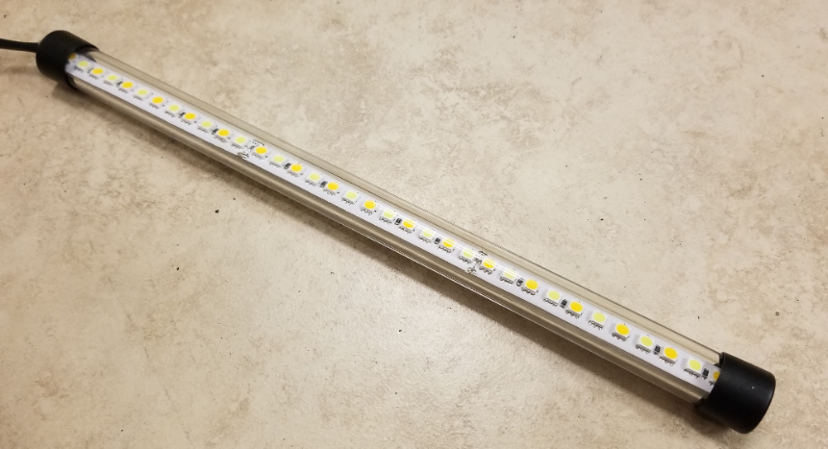
Tools:
- Wire Cutter
- Wire Stripper
- Wire Crimper
- Soldering Station
- Silicone
- Heat Gun
- Hand Drill
- 4.3mm Drill Bit

Procedure: | Inventory:
- Take LED strip and cut it to 12”, take care to leave some solder on both sides of the cut. | - 12” LED  (1300058)
- Cut semicircular plastic piece to 12” and sand until it fits snuggly into glass tube. | - 12” semicircular plastic  (1300059)  - 1 pre-cut glass tube  (1300060)
- Clean semicircular plastic with Windex and glue on LED strip.

- Cut two white AWG 20 wires and one blue AWG 20 wire to 12”. The LED has three leads, solder the white wires to the outer two leads and the blue wire to the center lead.

- Drill out one of the two end caps with a 4.3mm drill bit to pass the LED wires through. | - 2 plastic caps  (1300061)
- Insert the semicircular plastic with LED into the glass tube and apply silicone to both ends before closing the tube with the caps.

- Test the light with a 24V DC power supply.

LS-20 Spindle Assembly
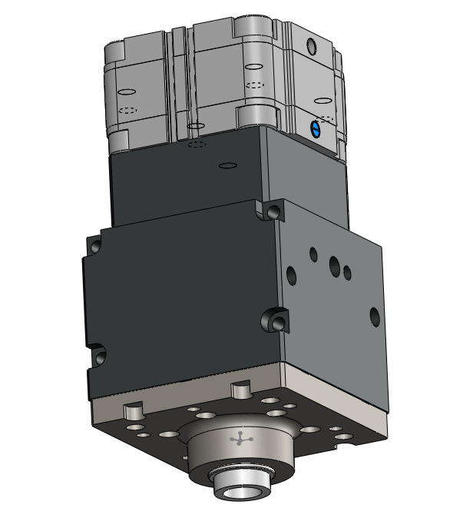
Tools:
- 4 mm Allen Wrench
- 5 mm Allen Wrench
- KM4 Wrench
- KM5 Wrench
- Blue Loctite
- Oil
- High Speed Grease
- Syringe
- Rough & Fine Sandpaper
- Mineral Spirits
- Cotton Balls
- 10 mm Wrench
- Beaker

Procedure: | Inventory:
- Check spindle nose for correct tolerance (47+0.02) mm. Test fit bearing into nose to verify. Use honing tool for hand drill and oil if tolerance is not met. | - 1 LS-20 Spindle nose  (1600001)
- Check all bearings, magnet, and magnet balancer slide into the spindle shaft. Hone shaft in the manual lathe with fine sand paper if anything doesn’t fit. | - 1 LS-20 Spindle shaft  (1600004)
- Break spacer bearing and sand to size (inner race 0.01-0.015 mm smaller than outer race). Each individual race must have a maximum height error of 0.005 mm along its circumference. | - 1 Spacer Bearing  (1600014)  (1600015)
- Apply red Loctite to magnet balancer and mount to motor magnet, let it dry while mounted to the spindle shaft to ensure it dries straight. Once dry, use balancing bar to balance magnet by adding set screws. | - 1 Magnet balancer  (1600007)  - 1 Motor Magnet  (1600007)
- Once all tolerances are met, clean spindle shaft and nose with acetone. Blow parts with compressed air to get rid of any remaining imperfections.

- Clean Nachi precise bearings with mineral spirits by soaking a cotton ball and dripping the inside of the bearing. Use a beaker to catch the used spirit. Use compressed air to dry the bearings. | - 1 Nachi bearing set  (1600002)
- Apply a small amount of thermal grease with a syringe, just enough to evenly cover both races and ball bearings.

- Assemble the two precise bearings and bearing spacers into the spindle shaft. The arrows on the outside of the two precise bearings should point towards each other.

- Install KM5 nut with flat side facing up and small amount of blue Loctite on threads. | - 1 KM5 nut  (1600006)
- Apply a thin coat of oil to the inside of the spindle nose and insert spindle shaft assembly into it. Push the assembly in very carefully to avoid it from getting jammed.

- Install bearing support to spindle nose. Tighten screws and check the spindle spins smoothly. | - 1 bearing support  (1600017)  - 4 M5X10 socket screws  (1100014)
- Mount spindle assembly sideways on a vise, place dial indicator at the tip of the shaft and rotate the spindle. The max error allowed is 0.02mm wobble. Once the tolerance is met remove one screw at a time and apply blue loctite before re-installing.

- Insert motor magnet with balancer to shaft.

- Install two upper bearings with 0.1 mm spacer between them. Add encoder spacer on top of the bearings. Finally screw in KM4 nut, do not tighten too hard since the nut will be removed to install the encoder later. | - 1 KM4 nut  (1600005)  - 2 upper bearings  (1600003)  - 1 0.1mm washer  (1600029)
- Grab a mill winding and wrap the red, white, and black wires with 8” of heat shrink starting from the base. | - 1 Mill Winding  (1600007)
- Take an LS-20 spindle headstock and test fit the upper bearing to ensure the tolerance is met. Hone if necessary. | - 1 LS-20 headstock  (1600024)
- Clean spindle headstock with acetone, use compressed air to dry.

- Insert the winding into the headstock, make sure the wires don’t stick out in the middle of the winding to avoid damage from rubbing against the motor magnet.

- Once winding is pushed all the way in, insert M6X10 set screws with blue loctite to hold it in place.

- Dab the upper bearings with a little blue Loctite to prevent slipping when the spindle is on.

- Insert hypalon winding cover and mount spindle assembly. Avoid hitting the magnet against the winding on the way in. | - 1 Hypalon winding cover  (1600013)  - 4 M6X20 socket screws  (1100030)
- Rotate the spindle to make sure it feels smooth, a kink or uneven tightening of screws might cause it to get rough.

- Extend the spindle wires by soldering the pre-cut 6 lead gray wire plus the 38” black, red, and white cables.

- Screw in water plug to the back face of the headstock, wrap in Teflon before inserting. | - 1 Water Plug 1/8” NPT set screw.
- Take a pull stud and cut one of the threaded sides to only 6mm of thread remaining. Clamp pull stud to vise and apply red loctite to the short thread. Screw in tool puller with a vise grip plier until the stud starts rotating in the vise. | - 1 Pull Stud  (1600008)  - 1 Tool puller  (1600008)
- Check that a tool holder goes into the tool puller without any resistance or jamming on the way in or out. If honing is required, mount in manual lathe and run while hitting the inside of the tool puller with a dremel rotating in the opposite direction.

- Take a pull stud assembly and sand the outside to fit snuggly into the spindle shaft. Make sure to clean the surface before testing it to keep the inside of the shaft clean.

- Grab three 1/8” steel balls and make sure they don’t fall through the tool holder. Remove the balls. If all three holes are good, apply grease to the tool holder and insert the balls back in. | - 3 1/8” steel balls
- Insert pull stud assembly into spindle shaft. Grab 10 bags of conical washers and start sliding them in from the top. Make sure to change the concave side, first two face up, second two face down. Repeat until all bags are used, add a few drops of oil every eight washers. | - 120 conical washers  (1600010)
- Screw in an M6 nut to the top of the pull stud to prevent it from slipping out. More washers may be added when the tool change is calibrated. | - 1 M6 nut  (1100055)

Wiring LMV-F400
Tools:
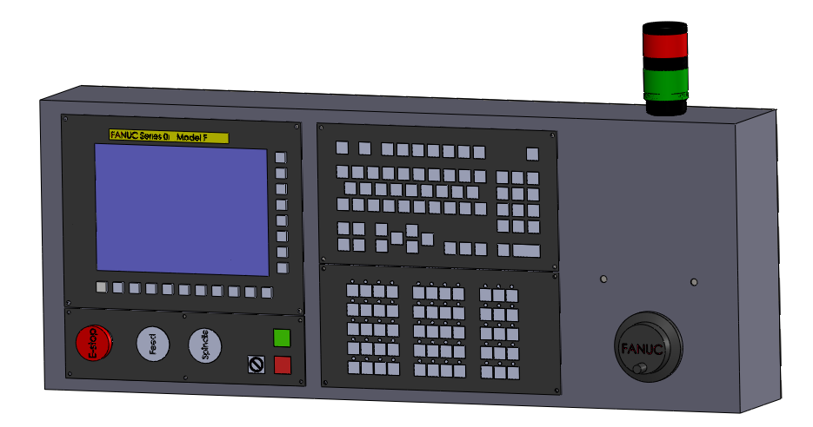
- 3 mm Allen Wrench
- 4 mm Allen Wrench
- 5 mm Allen Wrench
- Flat Screw Driver
- Wire Cutter
- Wire Stripper
- Wire Crimper
- Wire Peeler
- Molex Pin Tool Crimper
- Ferrule Crimper
- Soldering Station
- Drill
- 4.3mm Drill Bit
Procedure: | Inventory:
- Cut wires to desired lengths listed in inventory section. The numbers in parenthesis are sub-divisions of that wire. | - 2 Power cords (1300005)  - 1 DB9 (1300057)  - (6 wire) Gray - 188” (150)(38) (1300046)  - Vafam – 165” (1300047)  - (Black & Red) Coleman – 145” (62)(41)(42) (1300050)  - 1.5” ID hose for wires – 45” (1300071)  - Ribbon Cable – 42” (1300048)  - 3 wire gray – 251” (1300045) (39)(30)(130)(20)(10)(10)(12)  - Yellow Hose – 172” (1400027)  - Blue Hose – 324” (118)(40)(42)(61)(63) (1400036)  - Black AWG 12 – 24” (12)(12) (1300053)  - Black AWG 14 – 92” (30)(38(1300027))(12)(8)(4) (1300053)  - Black AWG 20 – 35” (12)(3)(3)(5)(5)(5)(5) (1300052)  - Gray AWG 14 – 78” (30)(12)(12)(12)(8)(4)  (1300055)  - White AWG 14 – 42” (38)(4) (1300052)  - White AWG 20 – 13” (6)(7) (1300052)  - Blue AWG 14 – 4” (1300082)  - Blue AWG 20 – 54” (6)(6)(6)(12)(12)(12) (1300082)  - Red AWG 14 – 38” (1300083)  - Ground – 79” (16)(12)(14.5)(20)(10)(4)(2.5)(1300056)
- Grab a control housing and drill out 3mm holes to 4mm. Deburr all holes that were drilled. | - 1 Control Housing
- Locate CNC panel and install into control housing. This is the panel with the screen. | - 1 CNC Panel  - 4 M4 Lock-nuts (1100058)  - 4 M4X10 socket screws. (1100007)
- Take operating panel and fit to control housing. This is the keyboard. | - 1 Operating Panel  - 4 M4 Lock-nuts(1100058)  - 4 M4X10 socket screws. (1100007)
- Install I/O panel into control housing. This panel contains machine operation buttons. | - 1 I/O panel  - 4 M4 Lock nuts(1100058)  - 4 M4X10 socket screws(1100007)
- Install Manual Override panel into control housing. This panel includes the emergency button, feed and RPM manual overrides. | - 6 M4X10 button heads(1100115)  - 6 M4 lock-nuts(1100058)
- Locate MPG and fit to control housing using the screws, washers, and nuts provided by packaging. | - 1 MPG
- Install 0/24V bus into the control housing. Use a screwdriver to hold nuts in place while tightening the screws since ratchet sockets do not reach. | - 1 0/24V Bus(1300068)  - 2 M5X20 Button Heads(1100021)  - 2 M5 washers (1100075)
- Install Tower Light, keep light labels facing towards the back of the machine. | - 1 Tower Light(1300068)
- Use ground wires to connect all the panel grounds, each panel has a designated threaded hole or screw for grounding. | - Ground wire lengths:  14”, 3.5” and 2”
- Mount control housing to the machine’s tub. Screws should be pointing down, with the heads on the control side and the nuts on the tub side. | - 4 M6X12 socket screws(1100026)  - 4 M6 lock-nuts(1100056)
- Insert grommets from control housing to tub. | - 1 1” thin grommet  - 1 1” wide grommet  - 1 .5” wide grommet
- Take light assembly and install to the tub with the light facing down diagonally. Screws should be pointing up, with the nut on the control side. | - 2 1” clamps(1300062)  - 2 M5X16 socket heads(1100019)  - 2 M5 lock-nuts(1100057)
- Mount transformer to the bottom of the electronics cabinet in the tub. The 110V side (X side) should be facing out of the machine and the 220V side (H side) towards the wall of the tub. | - 4 M5X10 socket screws(1100014)  - 4 M5 washers x-large(1100075)  - 4 M5 lock-nuts(1100057)  - 1 500W transformer(1500011)
- Install the 20” 3 lead gray wire to the coolant plug. The bare wire will connect to the plug with lead 1 going to live, lead 2 to neutral, and ground to ground. Connect coolant plug to the side cabinet. | - 1 coolant plug(1500042)  - 2 M4X10 button heads(1100115)  - 2 M4 lock-nuts(1100058)
- Install grommet and power cord anchor to the side cabinet. | - 1 1” thin grommet  - 1 power cord grip(1500006)
- Cut about 10” from the female side of the power cord. Use the female side for the spindle driver power and pass the longer male side through the power cord anchor.

- Take the 39” 3 lead gray wire and connect it to the power cord with quick disconnect connectors.

- Grab a main switch and install both 12” black AWG 12 and gray AWG 14. Both black wires connect to the live leads and the gray wires connect to the neutral side. | - 1 main switch(1500008)
- Connect the 39” gray wire from the power cord to the switch with quick disconnects. Take the 12” 3 lead gray wire and connect it to the other side of the main switch, the grounds from each gray wire connect to each other.

- The 12” wire goes back down to the electronics cabinet to connect to the fuse and terminals. The ground connects to the power supply base.

- Install external battery case to side cabinet. | - M4x12 countersink screws (1100106)
- Install servo amplifiers to the side cabinet, they don’t need to be in any particular order, they are both the same. | - 2 Servo Amplifiers  - 4 M6X12 socket screws(1100026)  - 4 M6 Lock-nuts(1100056)
- Attach 24V power supply to power supply base. Install power supply base to electronics cabinet plate, making sure power supply labels face right towards the relays. | - 1 24V Power Supply(1500009)  - 1 P67-WL4C Power Supply Base(1000067)  - 4 M4x12 Socket Head(1100067)  - 2 M6x20 Socket Head(1100030)  - 1 P66-WL4C Electronics Cabinet Plate(1100066)
- Install fuse base, surge protector, 1.5” of din rail with 5 terminals, 2 relays, and an air solenoid to the electronics cabinet plate. Make all interconnections for the plate, look at diagram for instructions on component locations and wiring scheme. | - 2 Relays(1500010)  - 5 M4x8 Socket head (1100006)  - 1 M6X10 button head(1100024)  - 1.5” din rail(1300001)  - 5 wire terminals  1-ground term. (1300095)  1-live term. (1300096)  1-neutral term. (1300097)  1-OVDC term. (1300098)  1-24V term. (1300099)  - 2 Diodes(1300015)  - 1 Fanuc surge protector  - 1 15 amp fuse base(1500014)  - 1 M4X8 conical screw(1100143)  - 1 Air solenoid(1300004)  - 2 M3X25 socket screws(1100002)
- Mount electronic cabinet plate to tub. Make sure to add silicon to the mounting screw holes to avoid coolant leaks. | - 4 M6X16 button heads(1100027)  - 4 oversized M6 washers(1100075)
- Take the Y and Z servo wires (The longer two sets), as well as the DB9, yellow coolant hose, blue air hose, Vafam cable, 3 lead gray wire cable, and the 6 lead gray wire cable. Pass all these through the 1.5” cable hose, use baby powder to help wires pass.
- Install 1.5” hose base to the L beam. Pass the wires through the base and clamp the hose to the base. Zip tie the hose to the cable carrier screwed to the legs. | - 1 1.5” hose base(1300072)  - 2 Black Zip ties
- Install AMC driver to driver plate in the spindle driver area. The power plug for the driver should be facing the front of the machine. Screw driver plate onto L beams making sure wires underneath are neatly adjusted with zip ties. | - 1 AMC driver(1700013)  - 1 driver plate(1000030)  - 2 M6X10 socket screws(1100025)  - 6 M5X8 socket screws(1100013)
- Connect Vafam shielding to a ground wire, screw on the driver plate.

- Install air piston and 1” of din rail with 3 terminals to the air piston plate in the spindle driver area. | - 1 Air solenoid(1300004)  - 3 wire terminals  1-live term. (1300096)  1-neutral term. (1300097)  1-ground term. (1300095)  - 1 Air solenoid plate(1000030)
- Mount the spindle to Table Z and pass the wires through the cable carrier. The fixed end of the cable carrier should be on the spindle side with button heads, the flexible end on the servo Z base. Include the ribbon cable, 2 air hoses, the yellow coolant hose, and the temperature sensor wires through the cable carrier. The shorter air hose should come out of the cable carrier two links above the end piece. | - 13 links of cable carrier  - 1 fixed end piece(1300031)  - 1 90 degree play end piece(1300032)  - 2 M6X10 button head(1100024)  - 2 M6X10 socket screws(1100025)  - 2 M6 washers
- Press the ribbon cable with a servo module connector. Pass a 1.5”X1.5” heat shrink over the DB9 wire before connecting it and the ribbon cable to the servo encoder module. Place heat shrink over the module and apply heat. | - 1 Ribbon wire press connector  - 1 Encoder module(1300042)  Connector socket, 10 position, 0.1’ pitch 2 rows  (1300074)
- Make sure all wires are neatly adjusted with zip ties before screwing in the air solenoid plate. Install plate. | - 2 M6X10 socket screws(1100025)  - 4 M5X8 socket screws(1100013)
- Use Spindle Driver Area Wiring diagram to make all wire connections in the spindle driver area.

- Adjust spindle driver switches as shown in the diagram.

- In the control housing, solder the Vafam cable leads. The white cable to pin 5 and the red cable to pin 7 of a DB20 Fanuc connector. Also solder the DB9 to another DB20 connector, following the color scheme shown in the diagram.

- Install door sensor magnet to the machine door. Using the magnet as reference, glue the door sensor to the tub with double sided tape and a coat of silicon on the edges. Make sure sensor and tub areas are cleaned before gluing. | - 1 Door Sensor(1500016)  - 1 Door Sensor Magnet(1500017)
- Use Control Housing Connections diagram to wire the control housing area.

- Return to the electronics cabinet diagram and connect all missing wires that come from other areas of the machine.

- Add ground wires between the two servo amplifiers, transformer, and electronics cabinet plate.

- Pass two air hoses up to the control area and through the grommet to the tool rack area.

- Neatly adjust and zip tie all wires in the control housing and electronics cabinet.

Curtain Assembly
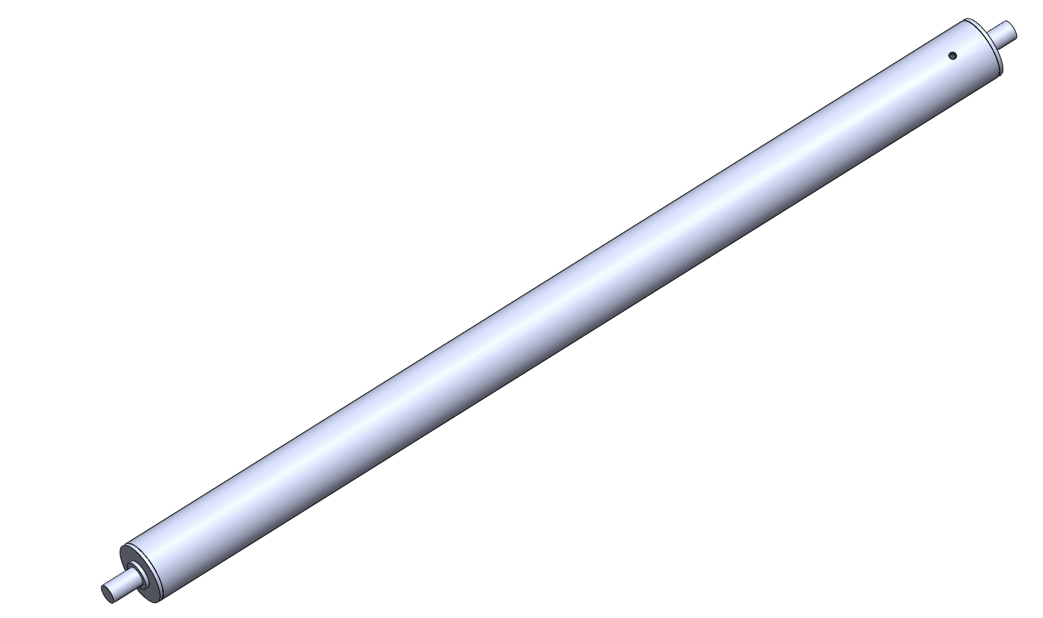
Tools:
- Phillips Head Screwdriver
- Hand Drill
- Blue Loctite
- Scissors
- Grease
- Acetone
- Silicone
- Masking Tape
- Paper Towel
- High Strength 90 Contact Adhesive

Procedure: | Inventory:
- Cut curtain spring to 12”. | - 12” Spring(1400010)
- Hold the big curtain spring base in a vise and apply blue loctite to the thread. Screw in spring into the base by hand. | - 1 Big curtain spring base(1000049)
- Take a curtain rod and slide a small curtain spring base through it, pass a curtain pin through both parts. | - 1 Curtain rod(1400005)  - 1 Small curtain spring base(1000050)  - 1 Curtain pin (1400008)
- Mount the spring on the vise with rubber guards and the curtain rod to the hand drill. Apply blue loctite to the small curtain spring base threads and screw it into the spring with the aid of the drill.

- Coat the spring with white grease.

- Insert the spring assembly into the curtain tube, make sure tube screw holes are on the side of the big curtain spring base. | - 1 Curtain tube outer shaft(1400004)
- Screw in the curtain base to the curtain tube. Sand the outside of the tube where the screws are so that the surfaces transition smoothly without bumps. | - 2 M3X6 conical screws(1100001)
- Press a curtain bearing on each side of the tube. The manual lathe can be used to press them. | - 2 Curtain bearings(1400007)
- Cut hypalon fabric into two rectangles 590 X 410 mm
- Place fabric into the laser to be cut into curtains. One should have the gray side up while the other should have the black side up, this is done to make mirror image pairs.

- Clean curtain tube with acetone.

- Apply contact glue to the outside of the curtain tube and to the curtain cut-out on the gray side, the glue should go the whole height of the curtain and until about 80mm from the side edge without the holes. This ensures there will be glue along the whole circumference of the tube as it is rolled in. Finally, roll the tube on the curtain, applying pressure to make sure both sides stick.

- Tape the curtains once done rolling to stop them from unrolling.

- Install curtain wiper to the left side of the tub. Push in towards the front of the machine as much as possible before tightening nuts. | - 3 M5X8 socket screws(1100013)  - 3 M5 lock-nuts(1100057)  - 1 Curtain Wiper(1500069)
- Install curtain bases to the sides of the machine, on the top base. Silicone them to the tub. | - 1 Left curtain base(1000044)  - 1 Right curtain base(1000045)  - 4 M6X20 socket screws(1100030)  - 4 T-nuts(1100061)
- Mount curtain T-blocks to the bottom side of the top base. Do not tighten all the way yet. | - 2 Curtain T-blocks(1000040)  - 4 M6X25 socket screws(1100031)  - 4 T-nuts(1100061)
- Install curtain triangle beams to the Y base, make sure to add curtain triangle spacers between the beams and the base. | - 2 Curtain triangle spacers(1000046)  - 2 Curtain triangle beams(1000043)  - 4 M5X25 socket screws(1100022)
- Screw in curtain holder beams to the curtain T-blocks. | - 2 Curtain holder beams(1000042)  - 4 M6X20 socket screws(1100030)
- Take curtain assembly and stick the curtain rod in the designated hole in the curtain base, use a piece of aluminum on top of the rod and tap it down with a hammer to jam the rod in the hole. Mount the curtain rod holder block to the top of the rod and screw it into the curtain holder beam. | - 2 Curtain rod holder blocks(1000041)  - 4 M5X20 socket screws(1100020)
- While pushing the curtain rod down, tighten the set screw in the curtain rod holder block. | - 2 M3X8 set screws
- Make sure the curtain holder beam as well as the curtain are vertical before tightening the curtain T-blocks.

- Installing the curtain to the curtain triangle beams will be done after cutting the table in the final touches section.
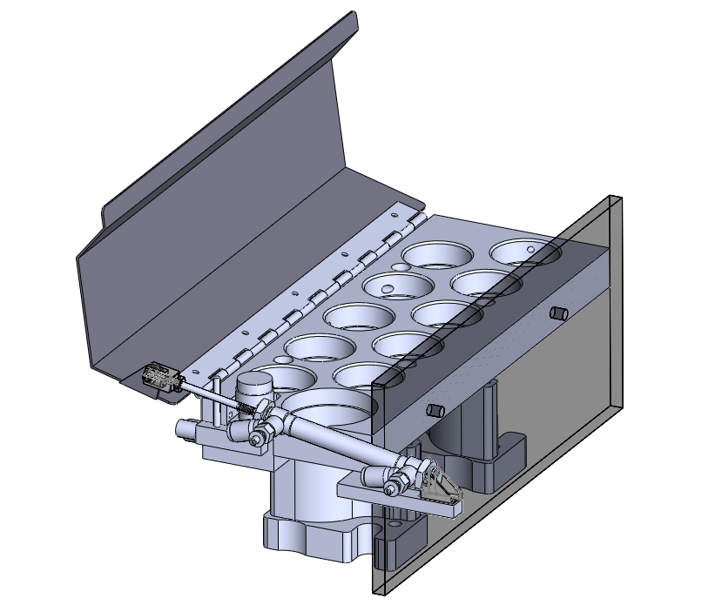
Tool Rack Assembly
Tools:
- 3 mm Allen Wrench
- 4 mm Allen Wrench
- 5 mm Allen Wrench
- Phillips Screwdriver
- 7 mm Wrench
- Scissors
- Loctite flexible adhesive
- Pliers

Procedure: | Inventory:
- Take tool rack plate and install shoulder screws, place a spring over each screw. Apply a few drops of blue loctite to the tool rack plate bases and screw in the shoulder screws to them. | - 4 M4X35 shoulder screws(1400063)  - 4 blue springs(1400061)  - 1 Tool Rack plate(1000124)  - 1 TR plate base right(1000105))  - 1 TR plate base left(1000104)
- Cut a hinge for the tool rack door so that five screw holes remain. Mount hinge to the left side of the tool rack and to the inside of the tool rack door. | - 9 M4X6 button heads(1100005)  - 5 M4 locknuts(1100058)  - 1 Tool Rack Door(1400009)  - 9” hinge
- Mount tool rack piston base. The screws go under the rack by the tool six position. | - 1 Tool rack piston base(1000107)  - 2 M4X16 socket screws(1100009)
- Cut rubber guard for the door and glue it to the edge of the door with loctite flexible adhesive. Use a very small amount of adhesive to prevent it from overflowing out of the guard. | - 9.5” rubber guard(1500044)
- Insert sleeve bushing to the tool rack door piston hole with pliers. | - 1 sleeve bushing(1400060)
- Mount pivot bracket to piston base, use the farther set of screw holes. | - 1 pivot bracket(1400058)  - 2 M3X6 button heads(1100004)
- Install Rod clevis and air valves to tool rack piston. Insert 4mm hoses to air valves followed by 4mm-8mm adapters and 8mm transparent hoses. | - 1 Rod Clevis(1400059)  - 2 4mm air valves(1400042)  - 2 1.5” long 4mm hose. (1500052)  - 2 4-8mm hose adapter(1400044)  - 2 11” long 8mm hose(1500051)
- Mount piston to the tool rack assembly, use pins with side guards for both ends. | - 2 Pins with guards set
- Install tool rack splash guard to the right side of the tool rack plate. Use an oversized washer on each side of the guard. | - 4 oversized M5 washers(1100048)  - 2 M5X12 socket screws(1100015)  - 1 Tool rack splash guard(1400008)
- Adjust the rod clevis on the piston shaft so that when the door is open, the first bend with the hinge sits horizontally. Apply blue loctite to rod clevis nut and tighten it.

- The tool rack adjustments and installation will be covered in the final touches section.

Final Touches
Procedure: | Inventory:
Loading Ladder and Parameters
- Before turning on the machine for the first time, insert the memory card labeled “Robot OI-MF Mill” and the production USB to the machine control.

- Press and hold the two rightmost soft keys under the screen and turn on the machine, hold the buttons until the system monitor main menu pops up.

- Go to option 7, SRAM data utility, and select it.

- Under the sub-menu select option 2, SRAM restore. Wait for it to complete and then select option 1, end, to exit the menu.

- Once the machine is on, press system, the soft key PMCMNT -> I/O. Use the arrow keys to navigate to the device section and select USB. Under the function section select READ.

- Highlight the file name section and press OPRT soft key followed by LIST, select the PMC LMV-F400 V1-C.MEM file.

- Press EXEC, wait for ladder to load and check on the top left of the screen for a label to go from Run to Stop.

- Go to PMCCNF -> PMC Status -> OPRT -> RUN. The label on the top left should go back to Run. The ladder must now be saved into the ROM memory.

- Navigate back to PMCMNT -> I/O, select Flash Rom -> WRITE -> EXECUTE.

- Repeat the process for the ladder to retrieve the IOCONF.000 file, execute it and immediately go to Flash ROM -> WRITE ->I/O CONFIGURATION -> EXECUTE.

- The machine should now be ready for operation.

Setting Home Position
- When the machine is turned on for the first time, the home position needs to be manually added. Using the large caliper, move the machine so it is 66mm from the left edge of the X guideway rails, 22mm from the top of the Z rails, and 225mm from the back of the Y rails. Go to System, type 1815 and the soft key No. Search, in parameter 1815.4 (APZ), change the 0’s to 1’s.

- Sometimes the control will say it is impossible to use that position for the home, turn off the machine and try again until it works. The machine needs to be restarted after the home is set. Check the Z position is still 22 mm from the edge of the rail, sometimes the ball screw will slip down when there is no power in the servo.

Tool Change
- Adjust the spindle tool change by setting the air pressure to 80 PSI and mounting the tool change piston with two screws, connect the air hose. | - 2 M8X110 socket screws(1100038)
- Tighten the pull stud nut sitting against the conical washers and add a locknut to the very top of the stud to avoid the air piston set screw from jamming on the stud. | - 1 M6 lock-nut(1100056)
- While tightening the pull stud nut, check the tool change clamps and releases a tool holder when the button is pressed. Adjust the nut until the tool holder barely releases at the press of the button at 80 PSI and does not release at 75 PSI.

- When the tool holder is released, the pull stud is pushed down into the spindle shaft, make sure the top of the nut is slightly higher than the top of the spindle shaft. If it is not the right height, adjust by adding or removing conical washers from the stud.

- Insert a pull stud washer between the pull stud nut and the top lock nut, once the tool change is adjusted and the height is set correctly, tighten the lock nut down. Avoid moving the pull stud nut in order to prevent readjusting the tool change.

- Check the tool change still works after tightening the nuts and mount the spindle alignment tool. Remove the tool change piston and cut the excess pull stud sticking out above the lock-nut.

Spindle Adjustment
- Make sure the spindle screws are tight. Set the dial indicator in the front of the alignment tool to measure the error in the YZ plane first, since it can only be fixed with shims.
- Set one end of the alignment tool to zero by rotating the spindle manually and moving the center of the wobble to zero. Move to the other extreme and rotate spindle again, the center of the wobble there is the spindle error in the YZ plane.

- Add shims accordingly to reduce the error to under 0.02mm per 100mm.

- Keep one spindle screw tight as a pivot point and loosen the other three, set the dial on the side of the alignment tool and repeat the process for the XZ plane. The error in this plane is fixed by how the spindle is tightened, that is why it’s done last.

- Once the spindle is aligned, mount the tool change piston and replace the alignment tool with the endmill. Remove the tool change piston.

- Press the emergency button and remove the power to the spindle driver before adjusting it.

- The spindle driver is analog and regulates the spindle speed based on voltage. 0V is the minimum speed of 0 rpm and 10V is the maximum speed of 14,000 rpm.

- Insert voltmeter leads into pin 2 (signal ground) and pin 4 (+ ref in) and measure DC voltage. Set speed to 14,000 rpm and make sure voltmeter reads 10V exactly, if not adjust parameter 3731. Set speed to 0 rpm and make sure voltmeter reads 0V, if not adjust parameter 3730. Go back and forth between max speed and min speed to get the right calibration because each parameter can affect the other slightly.

- Press the emergency button and reconnect the spindle driver.

- Run the spindle at 0 rpm, If the spindle rotates, adjust the test offset screw in the spindle driver with a flat screwdriver until it stops.

- Rotate the current limit screw clockwise until an audible click is heard.

- Rotate the loop gain screw clockwise until the spindle resists being moved by hand when at 0 rpm.

Cutting Work Table
- Insert wood wedge and C-clamp between two work table supports to minimize vibration when cutting.

- Warm up spindle at 1500 rpm for ten minutes before cutting the work table supports at 4000 rpm.

- Bring end-mill down to support using handle mode, once the tool starts cutting, change to jog and set feed rate override to 20 for cutting.

- Cut along the front base at the beginning of each work table support and compare to see which has the shallower cut, finish that work table support first to make sure the height of the cut doesn’t have to be adjusted later on.

- Use manual deburr tool to smooth out the edges of the table supports. Also deburr the top holes with the hand drill.

- Clean the cut surfaces with acetone and vacuum the rest of the aluminum shavings inside the tub.

- Silicone the two visible socket screws on the front base.

- Apply a thin coat of grease to the cut side of the work table supports before installing the table. The side of the table where the screw holes are closer to the edge should be on the left side. | - 1 Large work table(1000052)  - 12 M6X20 socket screws(1100030)
- Measure the surface of the table with the dial indicator to make sure table is flat on the supports.

- Mount tool change piston and remove end-mill from the spindle. Take the tool change piston back out.

Final Details
- Use the radial dial inside the spindle shaft to measure the run out error, mark it in the check list.

- In between jobs run the spindle, slowly crank up the speed to 14,000 rpm to have the excess tool change oil spill out.

- Mount front base splash guard by stacking 2 regular M6 washers behind an oversized ¼” washer. The plastic guard should wedge between the tub and the oversized washers snuggly, it should not be able to move easily. If the 2 washers are not enough, add a plastic M5 washer. | - 3 M6X10 button heads(1100024)  - 6 M6 washers(1100050)  - 3 ¼” oversized washers(1100074)  - 1 plastic splash guard(1400035)
- Remove circular base that comes with the vise and clean the bottom of the vise with acetone. Pass a parallel along the bottom surface to remove any small bumps.

- Once the vise is clean, coat the bottom with clean oil and mount to work table, use the washers that came with the vise plus a set of oversized M6 washers, | - 1 3” Vise(1400072)  - 2 M6X25 socket screws(1100031)  - 2 oversized M6 washers(1100074)  - 2 work table T-nuts(1100062)
- Open the vise and measure the back jaw with a dial indicator, move the indicator side to side to adjust the vise so that it is parallel to the x axis. Tighten the screws when the alignment is finished.

- Mount side window using side window brackets, make sure it is centered before tightening brackets and applying silicone to the window edges. | - 1 side window(1400022)  - 8 window brackets(1000062)  - 8 M5X8 button heads(1100116)
- After running the spindle for a while at max speed as mentioned in step 43, clean the excess oil from the top of the spindle.

- Mount encoder base with the sensor base pointing towards the back right side of the spindle. | - 1 encoder base(1600018)  - 2 M3X6 button heads(1100004)
- Remove KM4 nut in order to install encoder disk.
- Install 500 line encoder disk, leave set screws loose. Mount encoder sensor with screws provided. Check that encoder disk is centered in the encoder sensor. | - 1 500 encoder disk(1600018)  - 1 Encoder sensor(1600018)
- Add blue loctite to KM4 nut and re-install on spindle shaft. After the nut is tight, also tighten encoder disk set screws.

- Install encoder chip to encoder sensor. Press a connector to the ribbon cable coming out of the cable carrier and connect it to the encoder chip. The control should be able to read the spindle speed now. | - 1 encoder chip(1300042)  - 1 ribbon cable press connector(1300074)
- Set the spindle speed to 2000 rpm and check the spindle speed reading on the screen, if the numbers do not match, rotate the ref in gain screw in the spindle driver until they are the same.

- Run tap test to make sure the DB9 cable was soldered correctly, the max rigid tap error should not exceed 100 in the diagnosis section.

- If encoder works correctly, put on encoder cover and secure with screws provided. | - 1 encoder cover(1600018)
- Remove 10mm set screw from tool change piston and apply red loctite to it before re-installing.

- Take a tool change spacer and use it to gauge how low the set screw need to be in the piston. After the height is adjusted, disconnect the ribbon cable from the encoder so that the tool change spacer can be installed. Re-connect ribbon cable and set in the gap on the right side of the spacer before mounting tool change piston. | - 1 Tool change piston(1600016)  - 1 Tool change spacer  - 4 M8X110 socket screws(1100038)
- Apply silicone to the ribbon cable on the gap in the spacer.

- Install tool rack to the work table, use dial indicator on right edge to make sure it is parallel to the y axis. Before aligning make sure spindle shaft can reach the column for tools 7-11 without over-traveling in the x axis. | - 4 M6X20 socket screws(1100030)  - 4 work table T-nuts(1100062)
- Add oil to the transparent 8mm hoses coming out of the tool rack, open and close the tool rack door to get the oil inside the piston. Repeat until no more air bubbles come out.

- Connect the 8-6mm hose adapters and plug in transparent hoses to tool rack door air solenoid hoses coming out of the control housing.

- Open and close tool rack door while adjusting air valves on the piston until the motion is smooth and gentle, tighten valve nuts to secure calibration.

- Grab a tool holder and mount it to the spindle. Open the tool rack door and place the spindle right over the tool 1 position. Bring the tool holder down until it compresses the tool rack, then retract it 0.5mm in the Z axis.

- Go to system -> parameters -> 6031 and change the 900 to 0. This will turn off the protection to the tool change macros and allow editing.

- Go to offset -> macros and number 900 is the Z position for tool 1, type in Z and in the soft keys press Input C.

- Macro 901 is the tool clear height, take the value from 900 and add 60 to it.

- Macro 904 is the X position of tool 1, type in X and in the soft keys press Input C.

- Macro 905 is the Y position of tool 1, type in Y and in the soft keys press Input C.

- Test that the tool change works for tools 1, 6, and 9. Let the machine cycle through tools for a few minutes, adjust the Z position if needed so the tool holder barely compresses the tool rack when being taken or released.

- If tool change works, go back to system parameter 6031 and change the value back to 900 to protect macros.

- Finish installing the curtains by rotating six turns to create tension in the springs before removing the tape and screwing the hypalon to the curtain triangle beams. The left curtain rotate clockwise and the right curtain counterclockwise. | - 10 M4X6 Phillips screws(1100005)  - 10 M4 washers(1100045)
- Run the machine warm up program for 15 hours to make sure everything works correctly.

- Plug the coolant outlet from the tub and fill it up with water for a few hours while the warm up runs to make sure there are no leaks. The water level should be above the first two tub mounting screws on the left side of the machining area.

- Check the coolant plug is not reversed by plugging in the green tester and turning on the coolant. The tester lights will tell you if it is correct.

- After running the machine for 15 hours, check the ball screws and couplings for any loose screws.

- Check the ball screw end support pillows are working correctly by setting the dial indicator over the bearing covers and moving each axis, the bearings should not wobble more than 0.03mm.

- Adjust the backlash of each servo with parameter 1851, set the dial against the spindle and move it in 0.01 intervals. Move about 0.1mm one way and then retract it 0.01mm and make sure it moves the same amount in the dial as in the control.

- Clean outside of tub with acetone where the stickers will be placed. Install Levil logo to the control housing above the MPG. The LMV-F400 sticker goes to the right of the door, lined with the top of the door. The axis sticker is below the LMV-F400, about 2” away from the door. The eye protection and rotating cutter warnings will go under the axis sticker. The electrical hazard, 110V and coolant stickers go in the side panel. Finally the 90 PSI sticker will go above the air sensor on the back of the tub.

- Go to System -> PMCMNT -> Keep Relay and turn off the overrides for the door and air sensors by changing the 1’s to 0’s. Make sure the air sensor works by setting off the alarm when the air goes below 85 PSI. Also test the door sensor by opening the door in the middle of a program to make sure it stops.

- Install Ethernet base and main switch to the control housing back cover. Plug an Ethernet cable from the control to the base and make sure the replacement fuses are taped inside the control housing. Put the cover on. | - 1 Ethernet cable(1500047)  - 1 control housing back cover  - 1 Ethernet base(1500046)  - 16 M4X8 socket screws(1100006)
- Clean inside of side panel with acetone and mount shielding, cut to fit the inner area. Make sure there are no tools in the side cabinet before closing it with the side panel. | - 1 side panel(1400013)  - 12 M5X8 button heads(1100116)
- Clean inside of the L cover with acetone and mount shielding, cut to fit the inner area. Install L cover and vented back cover to the L beams. | - 1 L cover(1400020)  - 1 vented back cover(1400021)  - 20 M5X8 button heads(1100116)
- Cut rubber guard for the top of the tub to prevent vibrations from the top cover and glue it with loctite flexible adhesive. | - 24” rubber guard(1500044)
- Install top cover, angle it forward while pushing it in to make sure the lip goes under the rubber guard. | - 1 tub top cover(1400012)  - 5 M5X8 socket screws(1100013)  - 1 M5X10 socket screw(1100014)  - 1 M5 lock nut(1100057)
- Oil the guideway rails, spindle nose, and vise.

- Take a Levil USB from the tooling cabinet and the mill’s memory card and plug them to the control to do the backups.

- Repeat steps 2-3, under the sub menu, choose option 1, SRAM backup. Wait for the control to finish backing up then select option 1, end, to exit the menu.

- Once the machine is on, press system, the soft key PMCMNT -> I/O. Use the arrow keys to navigate to the device section and select USB. Under the function section select WRITE.

- Highlight the file name section and press OPRT soft key followed by LIST, select the LMV-F400 V1-C.MEM and IOCONF.000 files.

- In edit mode, go to System -> PARAMETERS -> OPRT -> F OUTPUT -> EXEC.

- Go to the computer and make a new file under client documents for the machine being backed up. Make a copy of all the files in the USB and memory card. Also save the SRAM backup from the memory card into the USB as well as the user manuals and required programs. The USB will leave with the machine.

- Go over the check list jobs to make sure no steps have been skipped.

Wiring Diagrams
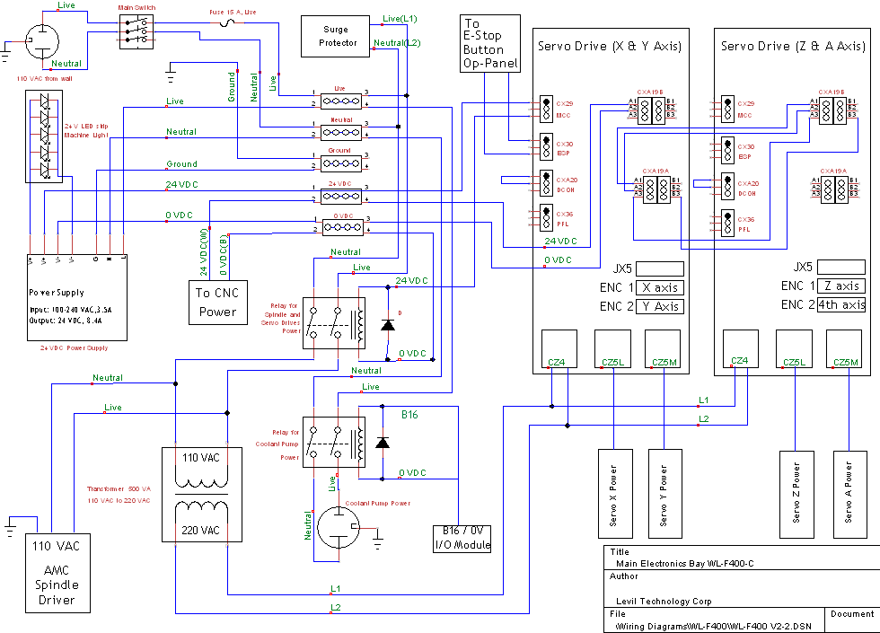
Electronic Cabinet Wiring:

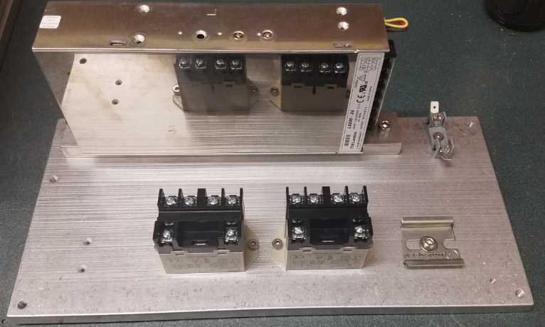
The components should be laid out in this manner:

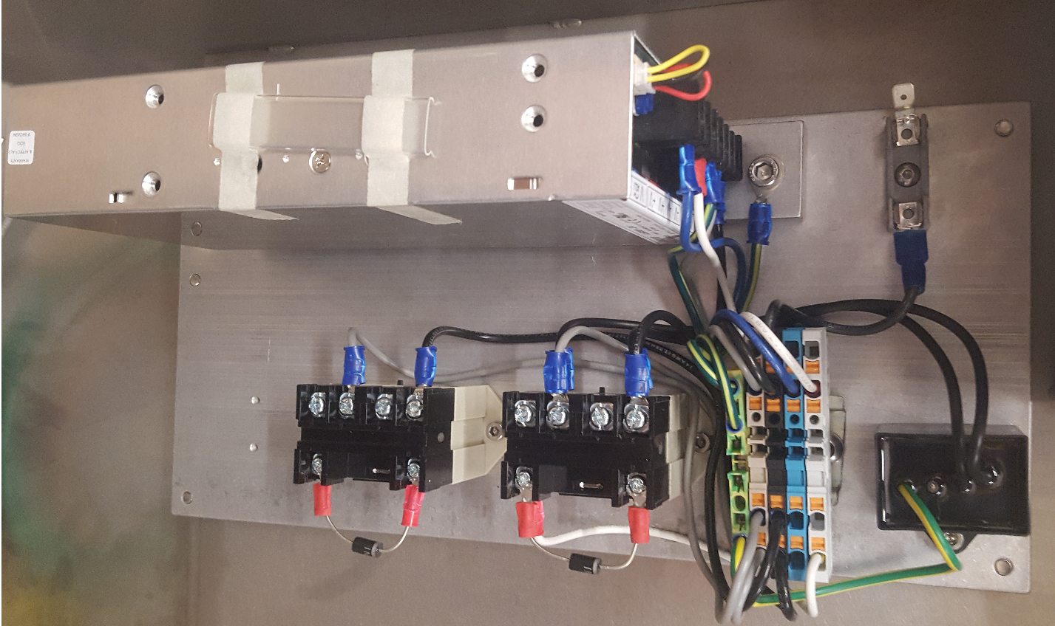

Input / Output Connections:
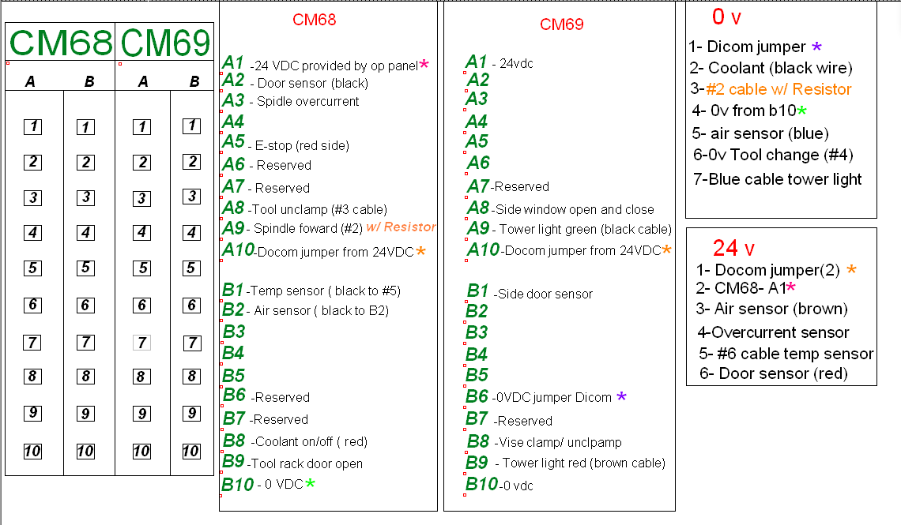
JA41 to Encoder Module Wiring:
Use the test board to figure out which color scheme to pick.
Function | DB9 | JA41 | Color Scheme 1 | Color Scheme 2 | Color Scheme 3
+5V | 1 | 9 | Brown | Black | Red
-Index | 2 | 17 | Red | Brown | White
+Index | 3 | 15 | Orange | Red | Green
0V | 5 | 16 | Green | Blue | Yellow
-A | 6 | 6 | Blue | Green | Orange
+A | 7 | 5 | Purple | Purple | Blue
+B | 8 | 7 | Gray | White | Purple
-B | 9 | 8 | Black | Gray | Gray

Control Housing Connections:
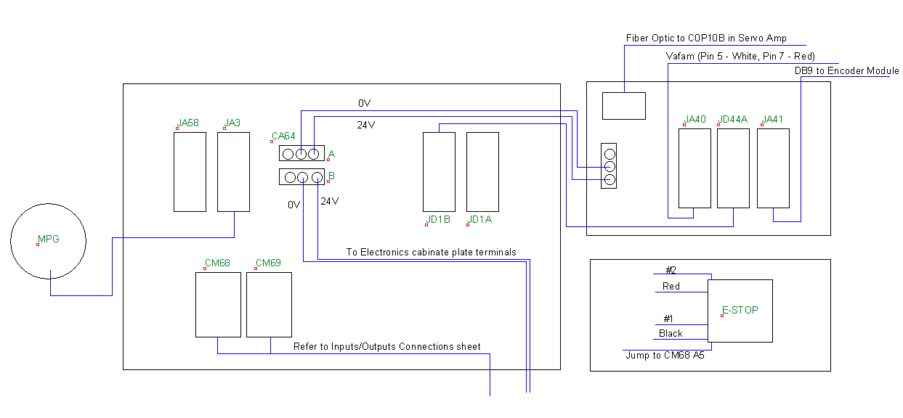
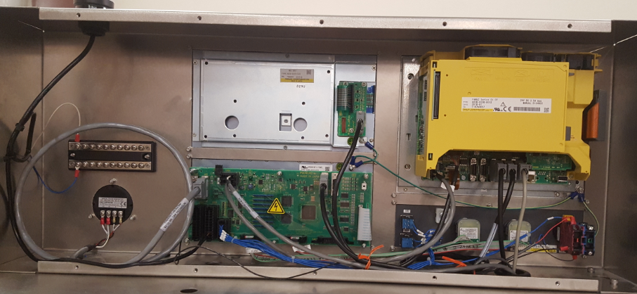
Spindle Driver Area Wiring:
